Distinctiveness Based Neural Network Pruning:
Facial Emotion Classification Network
Xingnan Pan

Research School of Computer Science, Australian National University, Australia
u6744662@anu.edu.au
Abstract. Although large-scale deep learning networks have achieved significant results in image recognition and natural language processing. However, the shallow neural network, due to its simple network structure and few parameters, still play a very critical role in the field of data science. As for how to construct a smaller shallow neural network, there is still no standardized method and principal explanation. The Distinctiveness method introduced by Gedeon is one of the popular pruning methods. This article uses the SFEW data set to build a three-layer basic shallow neural network, and uses Distinctiveness to try pruning on different hidden layer sizes in [16, 32, 64, 128], and compare the pruning effects. The results show that using Distinctiveness to prune the neural network has its limitations, but it can still effectively remove non-functional neural units and even improve the performance of the network.
Keywords: Neural Network, Facial Emotion Classification, Network Pruning, Distinctiveness.
- Introduction
In the past 10 years, machine learning and deep learning have become the hot spots of the times. Countries and companies are constantly exploring and seeking the transformation of data-driven business models. Among them, neural networks are the key to deep learning. However, the amount of data in deep learning models is often huge, often exceeding one million. This brings great challenges to network training and network deployment. Therefore, how to effectively reduce model parameters and model size has become one of the key issues in the development of neural network models. In this article, we use the SFEW facial expression data set to build a basic three-layer neural network, and try to use Distinctiveness to trim the network and remove the redundant units of the network. And compare the pruning effects of different hidden layer sizes.
- SFEW & pre-processing
The source Face Emotion dataset, Static Facial Expressions in the Wild (SFEW) [1] is used in this paper. The SFEW is extracted form a temporal facial expression dataset Acted Facial Expression in the Wild (AFEW) [3], in which the facial emotion images are extracted from movies. The images in the dataset are more natural and realistic because those images are captured in a close to real-world environment instead of lab-control environment.

In this paper, we will use PCA vector as the input of the classification model. The images in dataset are processed by two descriptors: LPQ [5] & PHOG [6] to generate the pattern vectors. In order to reduce the input data complexity, Principal Component Analysis (PCA) is applied for both pattern vectors. The first five components are kept which contain 98% of the variance. Therefore, the input dimension is 10 in total by combining two of first-five PCA vector.

The dataset has 675 items in total, and contains seven facial expression: Angry, Disgust, Fear, Happy, Neutral, Sad, Surprise
Data Normalization
The normalization is applied to the input by using (1) equation. Normalization can map input values in different dimension to similar range of values, leading each principal component to have similar contribution during the training neural network process. Also, the original PCA element value is small. For instance, the values in the first dimension have the range of [-0.0109, 0.0096]. Normalization can ensure the input roughly in the range of [-1, 1], which can allow the network to learn more quickly.

$$\overset{∼}{x} = \frac{x - μ}{σ}$$ | (1)

Where $\overset{∼}{x}$ means the normalized value, and $μ$ means the mean value, and $σ$ stands for standard deviation.
- Methods
Construct neural network
The way to determine a proper shallow neural network structure for a particular task remains infeasible. But this could be address by starting with a larger net and then prune it to the desired size to obtain proper size of the neural network for a particular task Error! Reference source not found.. In addition, Tom [2] concludes rules of thumb when starting with a smaller network and it fails to learn features (for feed forward fully connected network): adding one or two units; adding 10% extra units; or even to double the number of hidden units.

In this paper, in order to investigate the behaviour of hidden units in a shallow neural network, the network structure only contain Three layers: input layers, hidden layers and output layers respectively, the network structure shows in the Figure 1. The experiences will try through different hidden layer sizes to see how the hidden units would behave and try to prune those units that behave “badly”. The measurement of hidden units’ behaviours will be discussed in the following sections. The experience will try different hidden layer size: [16, 32, 64, 128], which the latter size just doubles the previous size.

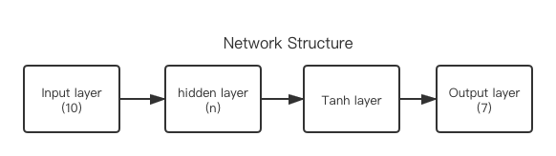
Figure 1. Network Structure
where the numbers in brackets represent the number of layer size. The activation function is Tanh function with the output range: [-1, 1].
Distinctiveness
Gedeon [2] introduce a method called “distinctiveness” to prune units in hidden layer in feed-forward neural network. The main idea of it is to remove the undesired units: the similar & complementary units and the non-functional units. The “similar units” is defined as two or more units that the same output or similar output for the same inputs. The complementary units represent that units have no function if they are group together, that is their outputs are complementary to each other. Alternatively, the complementary group could be grouped in two, three or more units. The non-functional units are the units that their outputs are bound to -1, or 1 (in the case using tanh activation function) which represent the units are always on or off; and the units always have zero output.

The distinctiveness of hidden units is to calculate the similarity between hidden units, which is determined by the unit activation outputs vector over the training set. Specifically, we construct output activation matrix $D$ by the formula (2), where $t$ is a vector that contain all the data in training set, the $i$ means the $i-th$ input data; $w_{ j}$ is the weights of $j-th$ hidden unit; $σ$ is the activation function. And then using the cosine similarity to calculate the similarity between units by the formular (3), where the $D_{:, m}$ is the m-th hidden units output vector over the training samples.

$$D_{ij} = σ(t_{i} * w_{ j})$$ | (2)
$$Cos(θ) = \frac{<D_{:, m}, D_{:, n}>}{|D_{:, m}| * | D_{:, n}|}$$ | (3)
The recognition of similarity of pairs of vectors is done by the angles, in which the angles can be retrieved by the formula (3). Since the tanh activation output range is (-1, 1) then the vectors angular range is [0, 180]. In Gedeon’s paper, outputs are generated by sigmoid function with the output range is (0, 1), hence the output vector need to be normalized by subtracting the output vector by 0.5. The pair’s angle less than 15° is considered these two units are sufficiently similar, hence one of them should be removed. In contrast, the pair’s angle great than 165° is considered the units are complementary to each other, thus both should be removed.
Sensitivity
Karnin [4] also introduce another way to prune neural network by the method call Sensitivity. The intuition of sensitivity is to remove the units that have least changes after training the neural network by a proper number of epochs. In other word, it literately removes the least the least sensitive unit until the network has the desired size. The sensitivity can be calculated by the formula (4), where the $S_{i j}$ is the sensitivity matrix, the subscript number i and j represent the unit j is connected to unit i via a synapse of weight $w_{ij}$; ∆$w_{ij}(n)$ is the change of weight of each update; $η$ is the learning rate; n is the number of training epochs; $w_{ij}^{f}$ means the final weight of $w_{ij}$ while the $w_{ij}^{i}$ is the initial state of $w_{ij}$. Yang [7] implements sensitivity on pruning the multiple-layer perceptron (MLP) network and the ResNet. In his paper, sensitivity can efficiently reduce the redundant connection in a large neural network, and accerlate the traning for the deep layers.

$$S_{i j} = ∑{[∆ w_{ij}(n)]}^{2}\frac{w_{ij}^{f}}{η(w_{ij}^{f}-w_{ij}^{i})}$$ | (4)
- Result and Discussion
Base model
Different hidden layer sizes have been tested: [16, 32, 64, 128]. The latter size just doubles the previous size. The network of this structure is constructed because it is hoped that by constructing a double size network, it could be more intuitively see the impact of different hidden layer sizes on the accuracy of the network, and compare the changes before and after the network pruning. For example, it could compare the result between the 32 hidden units’ network with the 64 hidden units after pruning.

Other relevant hyperparameter are listed here. Batch size is 16; learning rate is 1e-4.

Measurement of model. In this paper, the Accuracy is used as the main performance descriptor while the loss is the second performance evaluation factor. The experiences run though the five-fold cross validation script. The Accuracy is evaluated by the test set. The numerical results show in the Table 1. The results are the average value of five fold’s results. And the loss and accuracy curve show in Figure 2 and Figure 3.

The benchmark of the dataset in original paper is 19%, which is used non-linear SVM to classify. In comparison, it is surprising that the accuracy of all models has exceed 19% which can demonstrate that neural network has better Accuracy performance than SVM for this task. In the table 1, it is obvious that bigger network tent to have better performance than the smaller network or at least has similar performance. On the other hand, the 128 hidden dimension models on both epoch have the biggest test loss value.

Table 1. The results of different hidden layer size over 6000 and 4000 epochs.

Hidden size | Epoch 6000 |  |  |  | Epoch 4000
Hidden size | 16 | 32 | 64 | 128 | 16 | 32 | 64 | 128
Accuracy | 24.47 | 26.61 | 27.26 | 28.25 | 23.89 | 25.52 | 26.27 | 25.82
Train loss | 1.52 | 1.38 | 1.19 | 1.05 | 1.62 | 1.56 | 1.46 | 1.37
Test loss | 1.96 | 1.99 | 2.02 | 2.07 | 1.95 | 1.90 | 1.91 | 1.95

Overfitting issue. By analysing the Figure 2 & 3, it is considered that the models trained by 6000 epochs are sightly overfitted. By looking at the figure 2, the test loss curves of models remain stable at first 4000 epochs whereas it is obvious that the test loss significantly increases after 4000 epochs training. Also, the gap between test loss and training loss consistently increases with epochs. In the meantime, by looking the figure 3, although the accuracy is increasing slowly with training, there is no obvious difference between the accuracy at 4000 epoch and 6000 epoch, with the difference accuracy at about 1%.

Table 2. The range of distinctiveness angles of hidden units (fold 1)
Epoch | 16 | 32 | 64 | 128
6000 | [56.26, 124.32] | [28.53, 136.72] | [23.69, 163.01] | [30.77, 156.05]
4000 | [31.23, 126.60] | [36.07, 139.27] | [19.79, 147.54] | [22.34, 156.53]

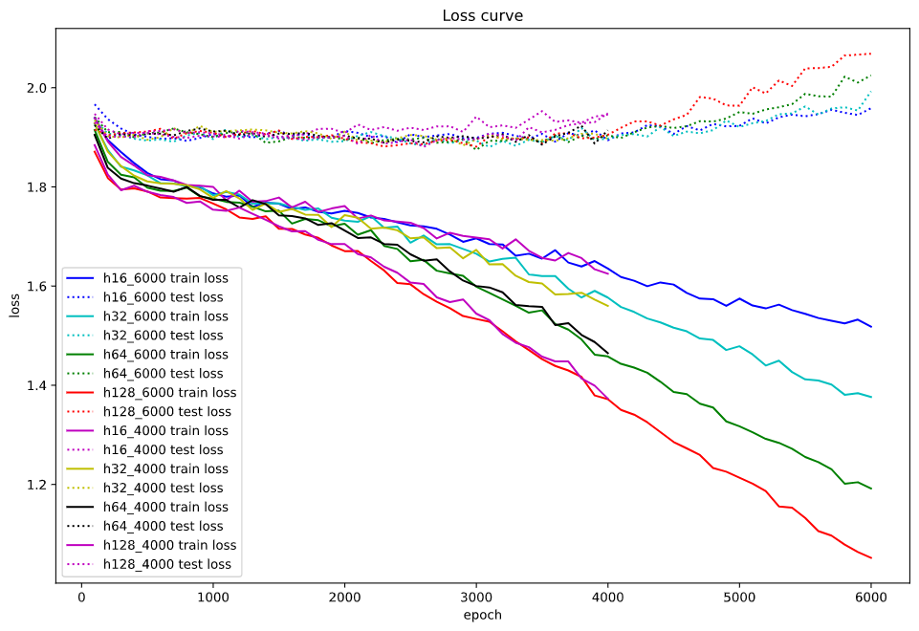
Figure 2. The training (solid line) and test (dotted line) loss curve over epochs
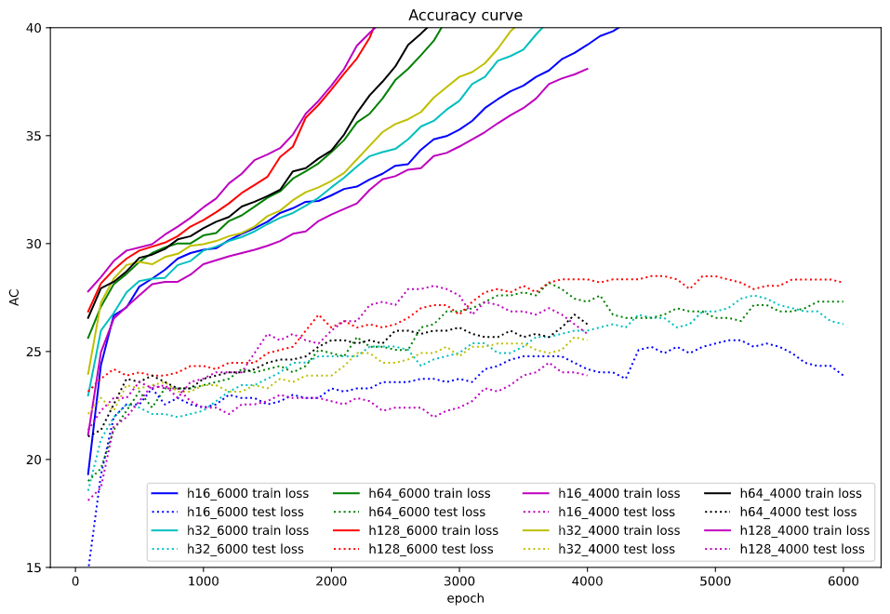
Figure 3. The training (solid line) and test (dotted line) accuracy curve over epochs
Distinctiveness similarity and pruning result
Distinctiveness similarity angles [2] are calculated by the formula (2) & (3). The main idea of distinctiveness similarity angle is to evaluate the similarity between the hidden units, and to remove the similar and complementary units. The result shows in the Table 2. In the original paper of distinctiveness, the pair of units, which angle is less than 15°, is considered that units are too similar; while if angle is greater than 165°, these units are considered is complementary to each other. However, in all models, no pairs of units that have this property. In other word, no pair of units have the angle that is less than 15° or greater than 165°.

In addition, it is strongly believed that the bigger networks must be able to be pruned in some way. The reason is: all the networks have a similar accuracy and their loss changes similarly during the training section. Meanwhile, the bigger network has twice or even more hidden units than the smaller networks. It is strongly believed that the bigger network could be pruned to half size or smaller and have similar accuracy after pruning. For example, in the table 2 epoch 4000, the model-128 has compromising performance than the model-64. Unfortunately, by looking at the results, it could be concluded that using the distinctiveness similarity is not a perfect way to pruning neural network.

Overfit vs. Distinctiveness similarity. By comparing the result of model between epoch 4000 and epoch 6000, it is not sufficient evidence to prove that overfitting has corelative relation with the bad evaluation performance of distinctiveness similarity, as both overfitted networks and non-overfitted ones do not match the conditions to prune using distinctiveness.

Some interesting patterns are found. The units of smallest network (model-16) are less similar and less complementary to each other compare to other bigger network; a network with more hidden units is more likely to have complementary units’ pair, but no sufficient evidence show that it is more likely to have similar units. This shows that to a certain extent distinctiveness still has a certain reference value on pruning neural network.

Table 3. shows the result of pruning network using modified angle range. That is, the angle of similar units has increase to less than 30°; the angle of complementary has decrease to 150°. In the table 3, one Similar Pair may contain two or more unit, then only keep one unit in a pair, the remaining units will be removed. The pruned AC means the test accuracy without retraining and similarly the pruned loss. The Remove Units contains two parts of units: the complementary units and the units needed to be removed from similar pair. Though in original distinctiveness paper [2] networks are unnecessary to re-train, we still try to retrain the network by 500 epochs. However, neither the network without nor with retraining, the performance might significantly decrease or have sight increase.

Table 3. The result of pruning networks by distinctiveness angle (fold 1)
Epoch | 6000 |  |  |  | 4000
Hidden size | 16 | 32 | 64 | 128 | 16 | 32 | 64 | 128
Similar Pairs | 0 | 1 | 1 | 0 | 0 | 0 | 2 | 3
Remove units | 0 | 1 | 3 | 10 | 0 | 0 | 2 | 18
Accuracy | 26.67 | 27.41 | 28.89 | 30.37 | 28.89 | 27.41 | 28.15 | 26.67
pruned AC | 26.67 | 30.37 | 25.19 | 21.48 | 28.89 | 27.41 | 28.89 | 25.19
Retrained AC | 28.15 | 28.89 | 28.15 | 28.89 | 31.85 | 27.41 | 26.67 | 24.44
loss | 1.96 | 1.99 | 1.96 | 2.03 | 1.91 | 1.85 | 1.9 | 1.91
pruned loss | 1.96 | 2 | 2.07 | 2.2 | 1.91 | 1.85 | 1.92 | 2.07
Retrained loss | 1.98 | 2.01 | 1.98 | 2.05 | 1.93 | 1.87 | 1.92 | 1.93
Non-functional units and pruning result
The distinctiveness also prunes the non-functional units. That is, those units’ output is band or close to the value of [-1, 0, 1]. This could be calculated by the distinctiveness activation output matrix $D$. If the mean value of $D_{:, m}$ is close to [-1, 0, 1], then the m-th unit will be removed. The result shows in Table 4.

The result is surprising that most models have a better or similar performance after retraining by 500 epochs. The best accuracy is 34.07% (model-128, with 6000 epoch and retrain 500 epoch), in which the accuracy increases by about 4% and the test loss decreases by about 0.05. The greatest improvement of Accuracy is about 5%. However, the loss has sightly increase at about 0.01. From the training epochs perspective, the change of accuracy of models trained by 6000 is higher than the models trained by 4000 epochs.

Other the other hand, few models have poor performance than before pruning. In conclusion, pruning the non-functional units is feasible and is likely to have better performance after retraining the network.

Table 4. The result of pruning network by Non-functional units (fold 1)
Epoch | 6000 |  |  |  | 4000
Hidden size | 16 | 32 | 64 | 128 | 16 | 32 | 64 | 128
Units prune | 1 | 2 | 5 | 24 | 3 | 7 | 15 | 20
Accuracy | 27.41 | 28.15 | 28.89 | 30.37 | 28.89 | 28.15 | 30.37 | 27.41
Retrained AC | 32.59 | 28.89 | 26.67 | 34.07 | 25.93 | 29.63 | 30.37 | 27.41
AC Diff | 5.18 | 0.74 | -2.22 | 3.70 | -2.96 | 1.48 | 0.00 | 0.00
Test loss | 1.92 | 1.97 | 1.95 | 2.03 | 1.89 | 1.83 | 1.90 | 1.91
Retrained loss | 1.95 | 1.98 | 1.96 | 1.98 | 1.90 | 1.84 | 1.91 | 1.93
Loss Diff | 0.03 | 0.01 | 0.01 | -0.05 | 0.01 | 0.01 | 0.01 | 0.02

- Conclusion and Future work
In this paper, we use facial emotion PCA value as the input to construct shallow neural networks for senven-class emotion classification. We experience on different hidden units size from 16 hidden units to 128 hidden units. Both four networks reach similar accuracy at around 25-27%, while the biggest network with 128 hidden units has the best average accuracy at 28.25% over five-fold cross validation script.

Thoughout our experiences, the distinctiveness is not a perfect good way to estimate the similarity of units, as no similarity angle of unit pair are in the rangle of less than 15° or greater than 165°, which is the determinating condition to prune in the original paper. No sufficient evidence shows that overfitting model has corelative relation with the badness result of the distintiveness similarity angle. If expanding the pruning anlge to less than 30° or greater than 150°, the network performance would significantly decrease with and without retraining.

In contrast, the distinctiveness can successfully find the redundant non-functional unit and efficiently improve the performance of network after retraining the network. The best result is 34% test accuracy with 4% of accuracy improvement compare before and after pruning.
Future work
Since the models have similar performance, it is believed that the pruning method still have a large space for improvement. In this paper, it only focuses on using a single method, distinctness, to estimate the redundant units. Hence, the combination of other methods, e.g. the sensitivity mention above, might be an advanced solution. Additionally, the iteration of pruning is also suggested. In other word, we can prune networks by training network, then pruning and repeat these steps unit the network has desired size.

Reference
- Dhall, A., Goecke, R., Lucey, S., & Gedeon, T. (2011). Static facial expression analysis in tough conditions: Data, evaluation protocol and benchmark. 2011 IEEE International Conference on Computer Vision Workshops (ICCV Workshops), 1–7. https://doi.org/10.1109/iccvw.2011.6130508
- Gedeon, T. D., & Harris, D. (1991). Network reduction techniques. In Proceedings International Conference on Neural Networks Methodologies and Applications (Vol. 1, pp. 119-126).
- Dhall, A., Goecke, R., Lucey, S., & Gedeon, T. (2011). Acted facial expressions in the wild database. Australian National University, Canberra, Australia, Technical Report TR-CS-11, 2, 1.
- Karnin, E. D. (1990). A simple procedure for pruning back-propagation trained neural networks. IEEE transactions on neural networks, 1(2), 239-242.
- V. Ojansivu and J. Heikkil. Blur Insensitive Texture Classi- fication Using Local Phase Quantization. In Proceedings of the 3rd International Conference on Image and Signal Pro- cessing, ICISP’08, pages 236–243, 2008.
- Bosch, A. Zisserman, and X. Munoz. Representing Shape with a Spatial Pyramid Kernel. In Proceedings of the ACM International Conference on Image and Video Re-trieval, CIVR ’07, pages 401–408, 2007.
- Yang, D. C. Sensitivity Based Network Pruning: A Modern Perspective.

